## Creating Custom Master Pages

**Lab Time**: 60 minutes

### Exercise 1: Examine the Starter Master Page

In this exercise you will work on a site that already contains a starter master page named **Wingtip.master**. The objective of the lab is for you to add CSS rules to add graphic images and a custom branding style to the site.

1. Open the **Lab 5** site at the URL of **http://[[COLLAB-SITE]]/Lab05** in SharePoint Designer. Click on the **Master Pages** link in the **Site Objects** section to view the collection of master pages. You should be able to observe that there is a fourth non-standard master page named **Wingtip.master**. Note that **Wingtip.master** has been configured as the default master page for the site.

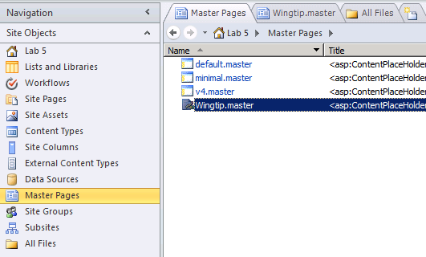

1. Note that through this entire lab you will not be required to make any modifications to **Wingtip.master**. Instead, all the required work will be done in a separate CSS file. However, you should still open **Wingtip.master** in Code View and take a moment to examine its contents, which represent a generic, reusable starter master page. One thing to note is that **Wingtip.master** already contains the following **CssRegistration** control that links to a custom CSS file named **WingtipMaster.css** that has been added at the root of the site.

<SharePoint:CssRegistration

name="<% $SPUrl:~Site/WingtipMaster.css %>"

After="corev4.css"

runat="server" />

1. In SharePoint Designer, click on the **All Files** link in the **Site Objects** section to view the files that exist at the root of the site. You should be able to see the CSS file named **WingtipMaster.css**.

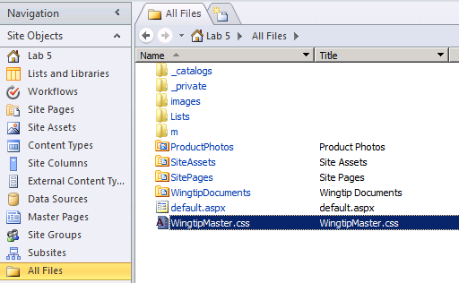

1. Open **WingtipMaster.css** in Advanced Edit Mode and examine its content. As you can see, the starting point for this CSS file contains the following CSS rules.

body {

margin: 0px;

height: 100%;

width: 100%;

overflow: hidden;

font-family: Verdana,Arial,sans-serif;

color: #666666;

background-color: white;

background-image: none;

}

form {

margin: 0;

padding: 0;

}

h1 {

font-weight: bold;

font-size: 1.2em;

margin-bottom: 0;

}

a, a:link, a:visited, .ms-WPBody a:visited, .ms-WPBody a:link {

color: #000022;

text-decoration: none;

}

a:hover {

text-decoration: underline;

}

p {

margin-top: 0px;

}

img {

border: none;

}

.customClear {

clear: both;

}

1. Using the browser, navigate to the Collaboration Site Collection, located at **http://[[COLLAB-SITE]]**. Next, navigate to the child site for **Lab 5** by using the global navigation menu of the top-level site. Inspect the user interface that is being generated by the current version of **Wingtip.master** and **WingtipMaster.css**. You can see that the user interface for the **Lab 5** site needs quite a bit of work. Over the remainder of this lab you will add new CSS rules to **WingtipMaster.css** to create the desired page layout for the new user interface.

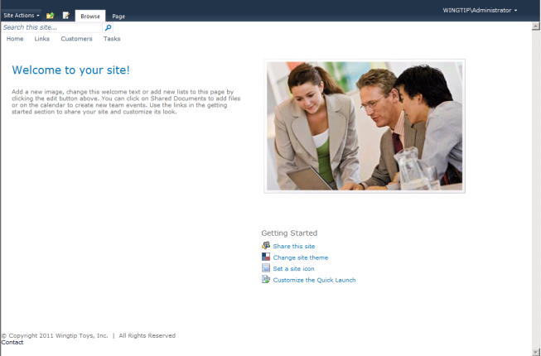

1. Note that the **Lab 5** site already contains a set of custom .GIF and .JPG image files that have been added to the **images** folder located at the root folder of the site. You will reference these image files in the CSS rules that you create and add to **WingtipMaster.css**. The following screenshot in SharePoint Designer shows the various image files in the **images** folder that you will be working with.

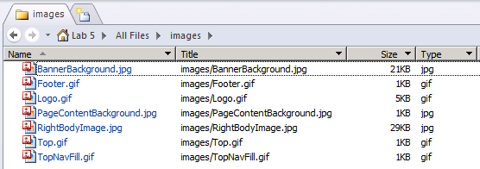

1. In SharePoint Designer, open **WingtipMaster.css** in Code View if it is not already open. Next, place your cursor at the bottom of this CSS file and add the following CSS rules to set the page width:

.customPageWidth {

width: 960px;

height: 100%;

margin: auto;

padding-top: 10px;

}

.customPagePadding {

padding: 0px 20px;

}

1. After you have made these edits, save your work in **WingtipMaster.css** and then refresh the browser to see the effect. The main content section of the page should now be centered with a fixed width of 960 pixels.

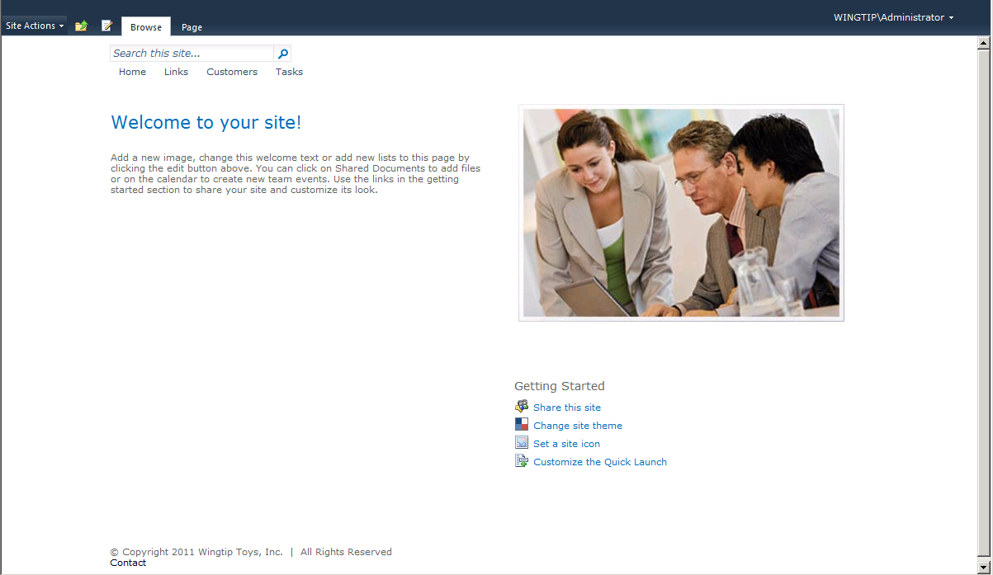

1. Now add the following CSS rules to **WingtipMaster.css** to add a background image and to style the top row of the page:

.customTop {

background-image: url('images/Top.gif');

background-color: white;

background-repeat:no-repeat;

height: 24px;

width: auto;

}

.customTop a {

color: white;

}

.customLogin {

background-image: none;

background-repeat:no-repeat;

background-color:#333333;

color: white;

float:right;

height:13px;

position:relative;

top:0px;

}

1. After you make this edit, save your work in SharePoint Designer and refresh the browser to see the effect of the new top row background image.

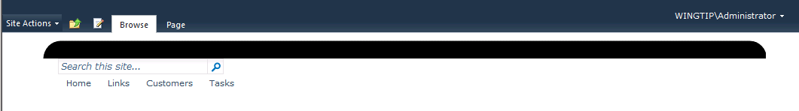

1. Now add the following styles for the banner section. After you make this edit, save your work in SharePoint Designer and refresh the browser to see the effect.

.customHead {

background-image: url('images/BannerBackground.jpg');

background-color: white;

background-repeat:repeat-x;

height: 96px;

width:auto;

}

.customHead a {

color: white;

}

.customLogo {

background-image: url('images/Logo.gif');

background-repeat: no-repeat;

background-color: transparent;

height: 91px;

width: 167px;

float: left;

position:relative;

top: 0px;

}

.customHeaderRight {

float: right;

}

1. After you make this edit, save your work in SharePoint Designer and refresh the browser to see the effect of the new CSS rules on the banner section of the page.

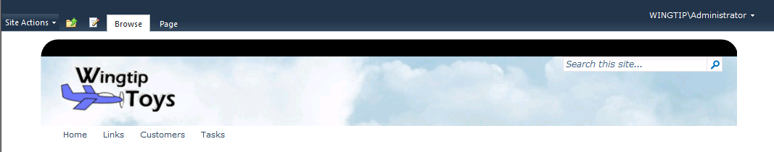

1. Now add the following CSS rules to style the search area:

.customSearch {

float:right;

position:relative;

top:64px;

}

.customSearchBox {

background-image: none;

background-repeat: no-repeat;

background-color: transparent;

height: 20px;

width: 180px;

float: left;

}

.customSearch input {

background-color:transparent;

border:0 none;

font-size:93%;

padding:4px 0 0 4px;

width:95%;

}

.customSearchGo {

float: left;

height: 20px;

width: 62px;

float: left;

}

1. After you make this edit, save your work in SharePoint Designer and refresh the browser to see the effect it has on the search box located on the right-hand side of the banner section.

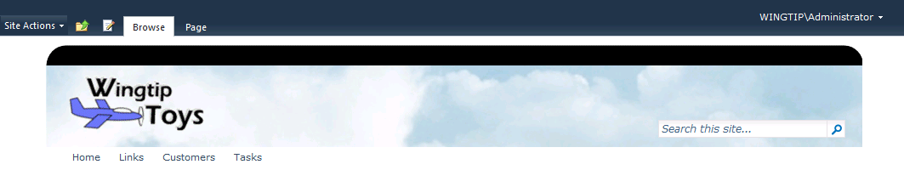

1. Now add the following CSS rules to style the global navigation section (aka Top Nav Bar):

.customNav {

background-image: url('images/TopNavFill.gif');

background-repeat:repeat-x;

background-color: black;

height: 24px;

border-style: none;

border-collapse:collapse;

}

.customTopNavHolder {

float: left;

}

/* Top Nav menu item */

.s4-tn li.static > .menu-item {

color: white;

white-space:nowrap;

border-style: none;

background-color: transparent;

padding:6px 20px 0px 0px;

display:inline-block;

vertical-align:middle;

font-size: 9pt;

font-weight: bold;

}

/* Top Nav menu item hover */

.s4-tn li.static > a:hover {

color: yellow;

text-decoration: none;

}

/* Top Nav menu item selected */

.s4-tn li.static > .selected {

color: #CEDFEF;

}

1. After you make this edit, save your work in SharePoint Designer and refresh the browser to see the effect it has on the global navigation section.



1. Now add the following CSS rules to style for the main body of the page that contains the content.

.customBody {

background-image: none;

background-color: white;

background-repeat: repeat-x;

min-height: 420px;

padding: 0px;

width: 918px;

overflow:auto;

border-color:#bbbbbb;

border-style:solid;

border-width:0 1px;

font-size:1.3em;

}

#PlaceHolderMain{

padding: 0px;

}

.customBody h1 {

font-size:175%;

font-weight:normal;

margin:2px 0 10px;

}

.customBreadcrumbs {

padding: 2px 0px;

}

.customBodyLeft {

float:left;

padding-right:60px;

vertical-align:top;

width:600px;

}

.customBodyRight {

float: left;

vertical-align: top;

width: 195px;

}

.customBodyImage {

padding-left: 4px;

}

1. After you make this edit, save your work in SharePoint Designer and refresh the browser to see the effect it has on the main body area of the page.

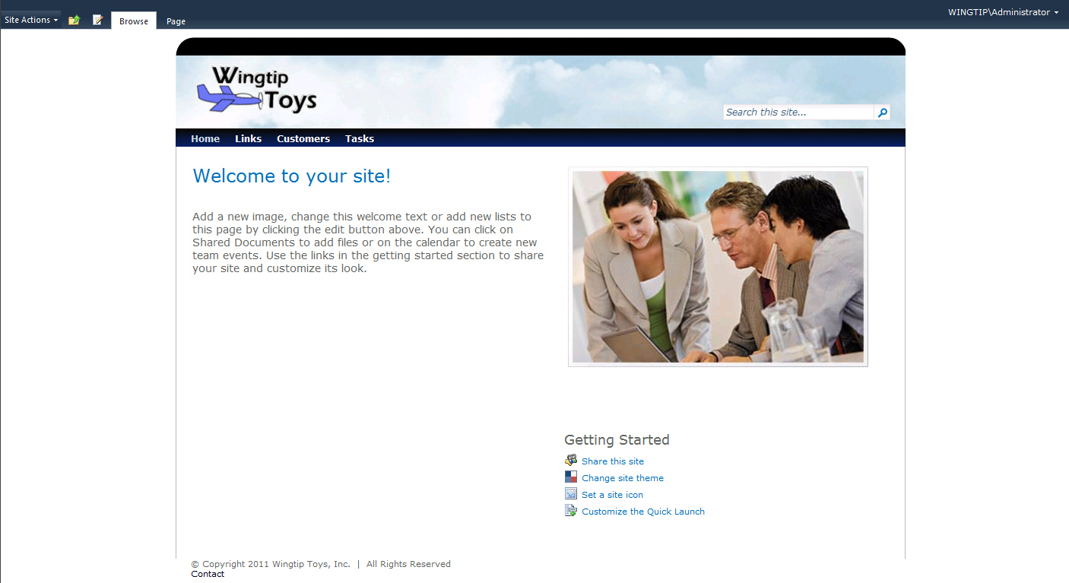

1. As a final step, add the following CSS rules to style for the page footer:

.customFooter {

background-image: url('images/Footer.gif');

background-color:white;

background-repeat: no-repeat;

color:white;

height:24px;

}

.customFooter a {

color: white;

}

.customFooterLeft {

float: left;

padding-top:4px;

}

.customFooterRight {

float: right;

padding-top: 4px;

}

1. After you make this edit, save your work in SharePoint Designer and refresh the browser to see the effect it has on the footer area of the page. You should now have a master page that is fully styled with a custom brand.

